# Kanban – Prospect

The prebuilt *Kanban – Prospect* provides an overview of registered prospects in your NetSuite account, with each Kanban column representing a prospect status. The last column contains two Kanban columns, stacked on top of each other, one representing prospect converted to customers and the other one records with the status *PROSPECT – Closed Lost* modified within the last month.

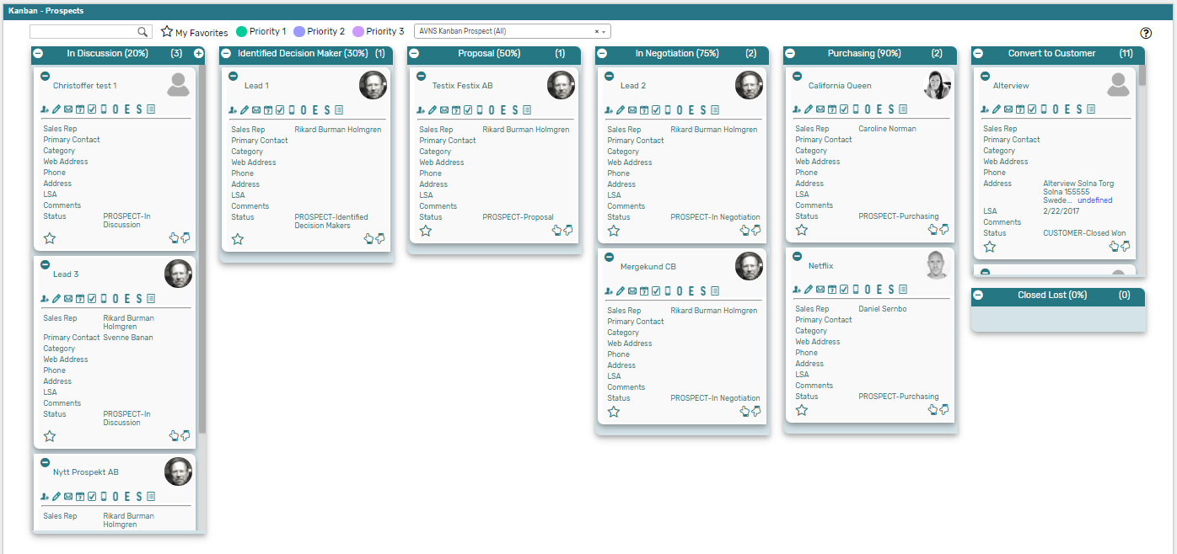

### Kanban – Prospects: Prerequisites

Before using the *Kanban – Prospect* board, please make sure the prerequisites listed below are fulfilled in order for the board to function as expected.

1. **Customer Status**  
   Since the columns of the prebuilt *Kanban – Prospect* board are based on NetSuite standard Customer status, it is important that the statuses presented in the board are available in your NetSuite account.   
     
   Navigate to Setup 🡪 Sales 🡪 Customer Statuses (Administrator) to find the list of Customer Statuses available in your NetSuite account. Compare the list from your NetSuite account with the Customer Status list which the prebuilt *Kanban – Prospect* board is based on (picture below).   
     
   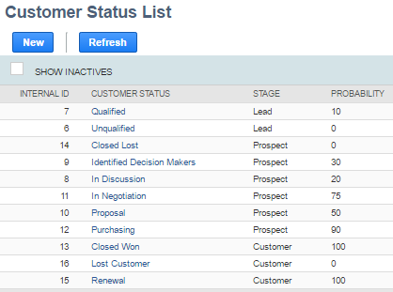  
     
   If the Customer Statuses differ between your NetSuite account and the picture above, you will need to edit the settings of the Kanban Columns for the *Kanban – Prospect* board.  
   ***Please refer to the section ‘Kanban Columns’ in the ‘Kanban User Guide’***
2. **Sales Rep & Sales Rep Image**  
   Make sure to mark the checkbox ‘Sales Rep’ on the Employee record for all available Sales Reps.   
   If an image has been uploaded to the *Image* field on the Employee record, this image will be displayed on the Kanban card. If no image is available, a predefined profile icon will be displayed instead.

### 

### Kanban – Prospects: Card Moves & Column Actions

The *Kanban – Prospect* board contains six Kanban Columns. Each column has been configured with one or several Column Actions. Double clicking on any card in the *Kanban – Prospect* board will open the prospect record in edit mode.  


1. **In Discussion (20%)**
   1. *Card Moves* – Kanban cards in the column *In Discussion (20%)* can be moved to all other columns in the Kanban board.
   2. *Column Actions* – when moving a Kanban card to the column *In Discussion (20%)* the status of the record represented in the Kanban card will be updated to *PROSPECT* – *In Discussion* and the Sales Rep will be set to *@MySELF@* (Current User).
   3. *Add Card* – it is possible to add a Kanban card (a new record) from the column *In Discussion (20%)* by clicking on the + icon in the top right corner of the column.   
        
      
2. **Identified Decision Makers (30%)**
   1. *Card Moves* – Kanban cards in the column *Identified Decision Makers (30%)* can be moved to all other columns in the Kanban board.
   2. *Column Actions* – when moving a Kanban card to the column *Identified Decision Makers (30%)* the status of the record represented in the Kanban card will be updated to *PROSPECT* – *Identified Decision Makers* and the Sales Rep will be set to *@MySELF@* (Current User).
3. **Proposal (50%)**
   1. *Card Moves* – Kanban cards in the column *Proposal (50%)* can be moved to all other columns in the Kanban board.
   2. *Column Actions* – when moving a Kanban card to the column *Proposal (50%)* the status of the record represented in the Kanban card will be updated to *PROSPECT* – *In Discussion* and the Sales Rep will be set to *@MySELF@* (Current User).
4. **In Negotiation (75%)**
   1. *Card Moves* – Kanban cards in the column *In Negotiation (75%)* can be moved to all other columns in the Kanban board.
   2. *Column Actions* – when moving a Kanban card to the column *In Negotiation (75%)* the status of the record represented in the Kanban card will be updated to *PROSPECT* – *In Discussion* and the Sales Rep will be set to *@MySELF@* (Current User).
5. **Purchasing (90%)**
   1. *Card Moves* – Kanban cards in the column *Purchasing (90%)* can be moved to all other columns in the Kanban board.
   2. *Column Actions* – when moving a Kanban card to the column *Purchasing (90%)* the status of the record represented in the Kanban card will be updated to *PROSPECT* – *In Discussion* and the Sales Rep will be set to *@MySELF@* (Current User).
6. **Converted to Customer**
   1. *Card Moves* – Kanban cards in the column *Converted to Customer* can be moved to all other columns in the Kanban board.
   2. *Column Actions* – when moving a Kanban card to the column *Converted to Customer* the status of the record represented in the Kanban card will be updated to *CUSTOMER – Closed Won* and the Sales Rep will be set to *@MySELF@* (Current User).
7. **Closed Lost (0%)**
   1. *Card Moves* – Kanban cards in the column *Closed Lost (0%)* can be moved to all other columns in the Kanban board.
   2. *Column Actions* – when moving a Kanban card to the column *Closed Lost (0%)* the status of the record represented in the Kanban card will be updated to *PROSPECT* – *Closed* Lostand the Sales Rep will be set to *@MySELF@* (Current User).

### Kanban – Prospects: Available Card Actions

The Kanban cards in the *Kanban – Prospect* board each contains ten Card Actions.

1. **Prospect: New Contact**Add a new contact to the prospect from the Kanban card.

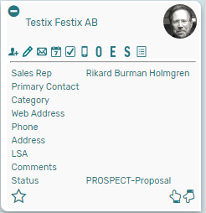

1. **Prospect: New Note**Add a new note to the prospect from the Kanban card.
2. **Prospect: New Email**Add a new email to the prospect from the Kanban card.
3. **Prospect: New Event**Add a new event to the prospect from the Kanban card.
4. **Prospect: New Task**Add a new task to the prospect from the Kanban card.
5. **Prospect: New Phone Call**Add a new phone call to the prospect from the Kanban card.
6. **Prospect: New Opportunity**Add a new opportunity to the prospect from the Kanban card.
7. **Prospect: New Estimate**Add a new estimate to the prospect from the Kanban card.
8. **Prospect: New Sales Order**Add a new sales order to the prospect from the Kanban card.
9. **Prospect: Show Activity**Show a list of all activities related to the prospect from the Kanban card.

### Kanban – Prospects: Alternative Searches

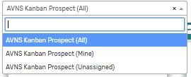There are three alternative searches for the *Kanban – Prospect* board.  
  
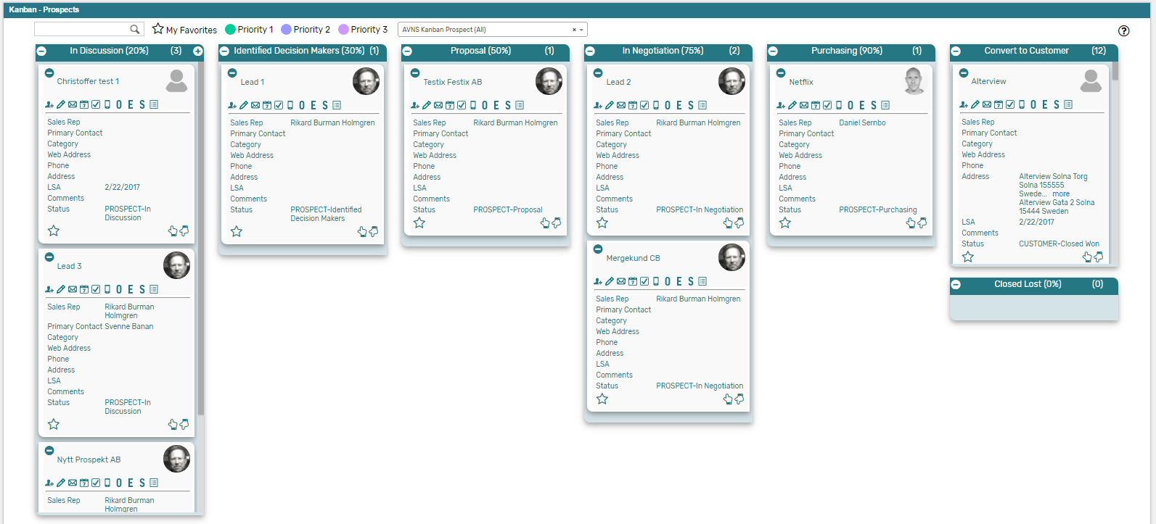

1. **AVNS Kanban Prospect (All)**This search will display all registered prospects in the *Kanban – Prospects* board.
2. **AVNS Kanban Prospect (Mine)**This search will display registered prospects where Sales Rep is *Mine* (current user) in the *Kanban – Prospects* board.
3. **AVNS Kanban Prospect (Unassigned)**This search will display registered prospects without an assigned Sales Rep in the *Kanban – Prospects* board.

### Kanban – Prospects: Available Colors

There are three colors available for the *Kanban – Prospect* board, which can be used to highlight and filter the Kanban cards (*Priority 1 // Priority 2 // Priority 3*). These are defined in the *Color* subtab of the Kanban configuration record.   
  
